ADS AI Sensor Placement Decisions and Rational

LiDAR Placement Requirements:
- Ideally should be as far forward on the car as possible.
- Needs to remain level.
- Should be as low to floor as possible while retaining a full 180-degree view in front of it.
- Very expensive and on loan from another company, so need to keep it safe (can’t be on front of the car if there’s a crash, because then FT is in debt).
- For mounting remember that there needs to be a direct line for fast wiring between it and the LiDAR box (space can’t just be left to run wire, the LiDAR will have to fit through gaps as well, maybe hatch somewhere?).
- Requires minimal vibrations to work well.

Zed2i Placement Requirements:
- Needs as clear a view of the road as possible – meaning a placement as high as possible (above driver?).
- Needs to remain level.
- Bolted USB-C cable used to plug in, no restraint on placement based on cabling but we would have to buy a dedicated ADS cable for it depending on placement (not issue, just to remember for assembly).
- Requires minimal vibrations to work well.
Note: Perfect camera placement should be akin to a driver’s vision while they are driving – but we cannot block the driver’s line of sight at all.

AI Computer Mount (Lunchy) Placement Requirements:
- Wiring can reach camera and LiDAR safely.
- Enough space surrounding mount for adequate airflow to/from components.
- Easy to access/remove for transport between AI-ADS and AI-DDT cars.
- Won’t become a projectile in the event of a crash.

Rough Illustrations of Car AI Sensor Placements
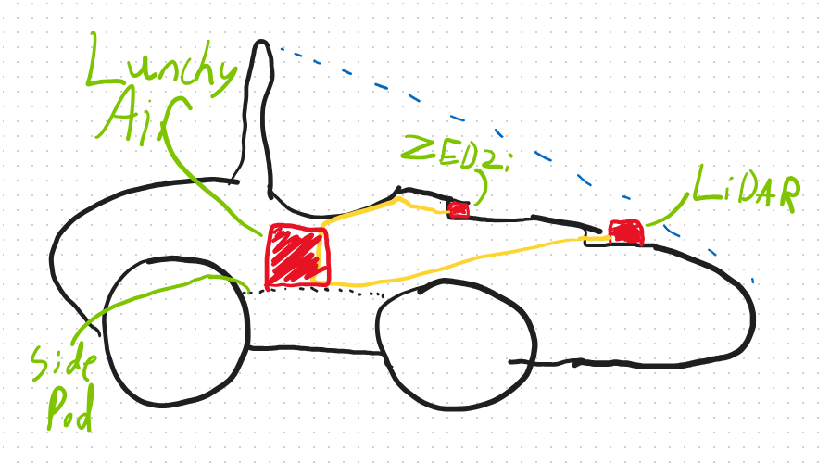
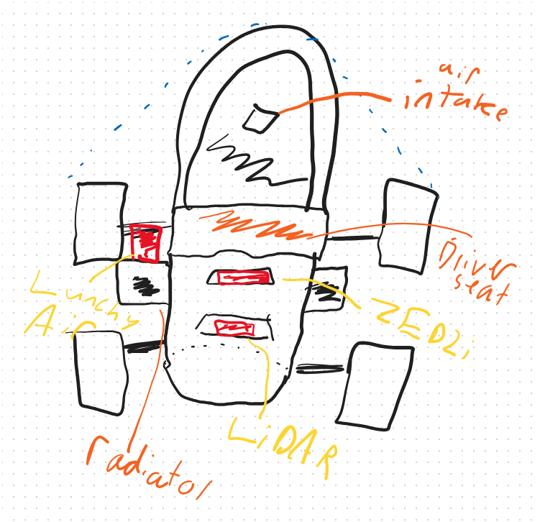

CAD View of Nosecone Car Loose AI Sensor Placements
(mm locations have yet to be made, will be done after discussion with Aerodynamics and electronics)
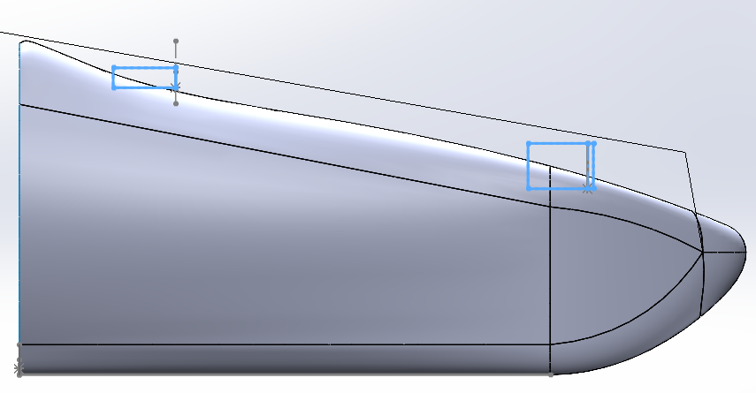
The uppermost line is the required Line of Sight of the driver
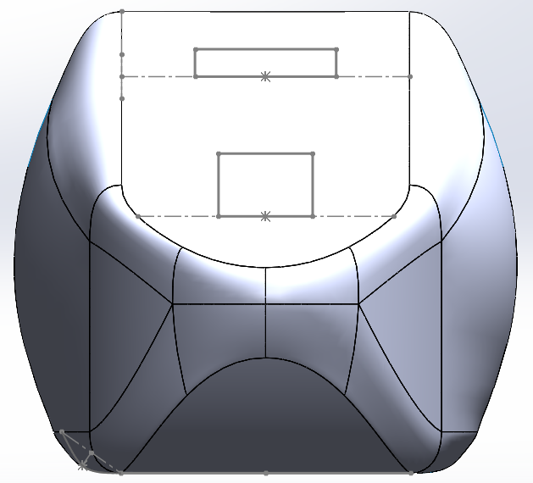

Rational:
The location for the LiDAR remains lower than and in front of the Zed2i to allow proper functioning of the AI stack. The LiDAR and Zed2i will both remain level to the ground in the design process. Mounting plates will be created that will have the nosecone overhang them and can be easily slid out for disconnecting the LiDAR when needed, allowing for waterproofing of the internal car body and removal of the LiDAR.
All components remain covered by the roll-hoop-to-chassis safety areas where they should not be damaged in the event of a crash.
Lunchy is placed on top of the left sidepod of the car when looking at it from the nosecone. This is mounted above the radiator with about 10cm between the top of the radiator and top of the nosecone, meaning heat should be mostly dissipated before reaching Lunchy. An aerodynamic box will be created (Lunchy Air) to cover the components, attempting to minimize aerodynamic impact of the box placement while also meeting waterproofing requirements. Placement of air vents will be required, as well as a cut in the carbon-fibre body of the car to feed cabling out of Lunchy Air and to the sensors and other components of the ADS car.
The choice to indent the sensors into the car as opposed to extrude them was done to meet the requirements of maintaining the driver’s line-of-sight, which would be an instant scrutiny fail if blocked. It also can mean an easier incorporation of a sunshade for the Zed2i while keeping both sensors level to the ground.
For the LiDAR, the only placement options feasible were along the nosecone – this location was chosen as it was as close to the front of the chassis as possible, and thus as low to the ground as possible, while remaining within the Surface Envelope defined by the FS-AI rules (between top of roll-hoop to end of chassis frame).
The Zed2i could have been placed anywhere along the same horizontal axis as the LiDAR, but making it higher gave better clearance and vision of the ground. It was not placed just under the roll-hoop due to the placement of the intake for the engine, which we were told should not be blocked. It is also untested if the distance between the Zed2i and LiDAR would cause parallax or other syncing issues between the sensors. For this reason, we chose to place it as high on the nosecone as possible. There was a box containing the electronics for the rest of the car sitting near the top of the chassis, so that box will be modified to have the front of it house the Zed2i, giving it a clean path to the rest of the car and a strong mount.
For mounting and dismounting, it could be useful to buy a second cable for the Zed2i which can be permanently kept on the ADS car, assuming budget allowed for it. It is not strictly necessary but would make mounting and dismounting in between cars faster. It would cost {price} to buy this cable. The AI car does not require a cable length greater than 40cm and our existing cable works on the ADS car, so cable length is not a constraint in buying a new cable.

